Software Architecture and User Interface Design

for

COSC Club Event Management System

**Prepared by**

| **Maria DeMelo** | **199695520** | **mdemelo@algomau.ca** |
| --- | --- | --- |
| **Emma Ude** | **199697810** | **cude@algomau.ca** |
| **Erfan Razavi** | **199658710** | **srazavi@algomau.ca** |
| **Jason Guo** | **199666070** | **yguo@algomau.ca** |

| **Instructor:** | **Amandeep S. Patti** |
| --- | --- |
| **Course:** | **COSC 3506** |
| **Date:** | **Feb 25, 2022** |

**Contents**

**CONTENTS II**

**REVISIONS II**

**1** **INTRODUCTION 1**

1.1 Document Purpose 1

1.2 Intended Audience and Document Overview 1

1.3 Definitions, Acronyms and Abbreviations 1

1.4 Document Conventions 1

**2** **SOFTWARE ARCHITECTURE 2**

2.1 Architectural Overview 2

2.2 Pattern Description 2

**3** **USER INTERFACE DESIGN 4**

3.1 System Description 4

3.2 Wireframe 4

**APPENDIX A - GROUP LOG 6**

# Introduction

## Document Purpose

*The purpose of this document is to present a detailed* description *of the software architecture and user design of the COSC Club Event Management System. It provides* a wireframe of the system as well as a detailed description of how to move between pages*.*

## Intended Audience and Document Overview

This document is intended for the CCMT, the Professor and the software developers. After the introduction, the document goes into the software architecture in Section 2, then the UI design is talked about in Section 3.

## Definitions, Acronyms and Abbreviations

*Below is a table of all the abbreviations and acronyms used in this SRS document:*

| CCMT | COSC Club Management Team |
| --- | --- |
| CCEMS | COSC Club Event Management System |
| COSC | Computer Science |
| UI | User Interface |

## Document Conventions

### Text Formatting Conventions

*This document follows the IEEE formatting requirements. The entire document uses Arial font. The font size for the text is 11 and italicized. The text uses Justify alignment and is single spaced. A 1” margin is maintained throughout this document.*

### Heading Formatting Conventions

*The headings are divided into Sections and subsections. The section headings have a font size of 18 and the subsection headings have a font size of 14 or 12. The headings are bolded with the section headings in white and the subsection headings in black. The section headings are center-aligned and the subsection headings are left-aligned.*

# Software Architecture

## Architectural Overview

This describes the framework of the CCEMS. The CCEMS will use a layered architecture pattern. This is one of the more common architectural patterns and works well for this particular product.

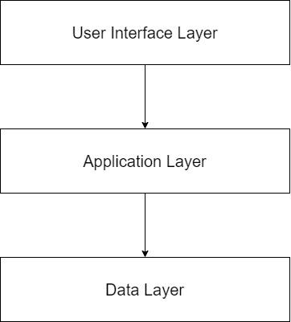

Figure 1: Layered Architecture

## Pattern Description

*The system* will have three layers:

1. User Interface Layer
2. Application Layer
3. Data Layer

### User Interface Layer

This is the front-end aspect of the CCEMS. This layer contains the parts of the system that the users are allowed to interact with. This is the third (highest) layer. It contains the menus, buttons and pages that make up the user interface of the CCEMS.

### Application Layer

This is the back-end aspect of the CCEMS. This layer contains the parts of the system that the users cannot access. It is the second layer and provides services to the UI layer. It contains the code that will be used to run the CCEMS.

### Data Layer

This is the database of the CCEMS. This layer contains the databases of information that are used in the CCEMS. It is the first (lowest) layer and provides services to the UI and Application layers. It contains the data, such as lists of members and financial statements for the CCEMS.

# User Interface Design

## System Description

The user interface will have an embedded system design. The user will be able to navigate through the system by clicking buttons that link pages together.

## Wireframe

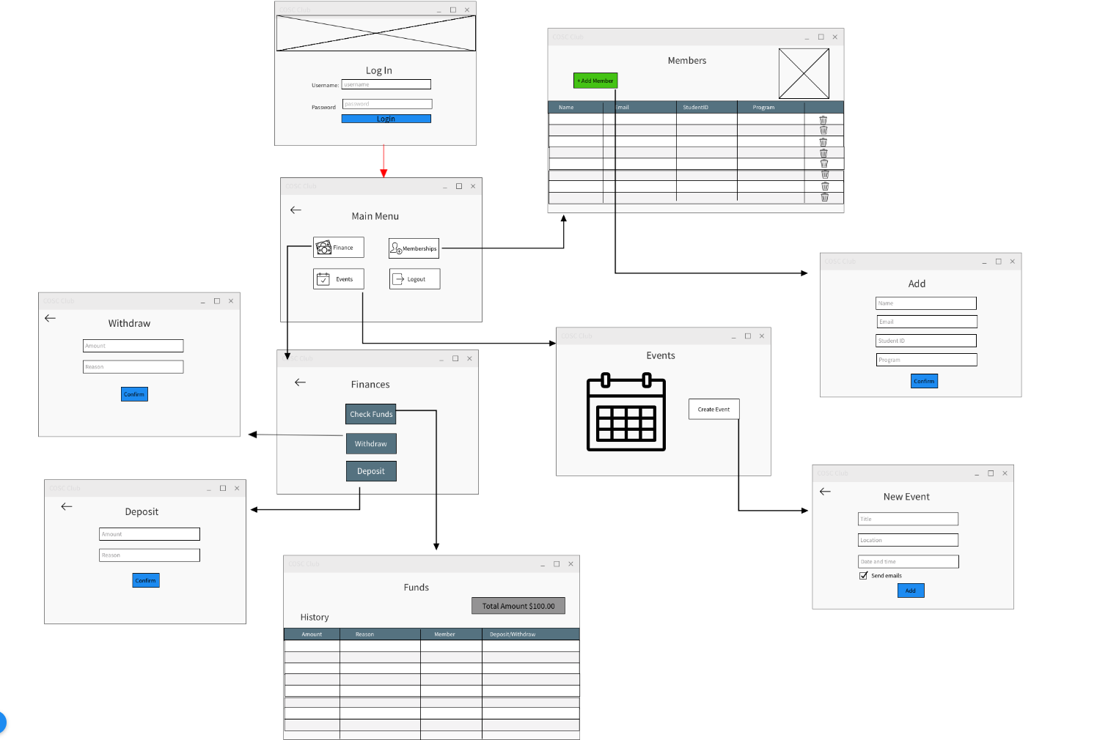

Figure 2: Wireframe

### Wireframe Descriptions

The system has ten distinct pages:

1. Login page
2. Main Menu page
3. Members page
4. Add page
5. Events page
6. New Event page
7. Finance page
8. Withdraw page
9. Deposits page
10. Funds Page

When the system is initially opened, the first page that the user encounters is the login page, where the username and password fields have to be entered. Afterwards the Main Menu page is opened. There are four buttons on the main menu page:

**1. Memberships Button**

This leads to the Members page. This page includes the members information such as their name, email, student id, program and an **Add Members button**. This button leads to the Add page which allows the user to add a new member to the membership list.

**2. Finance Button**

This button leads to the Finance page. This page contains three buttons;

**Check Funds button** which takes the user to the Funds page. The Funds page shows the total amount of the funds we have and the history for each amount and a reason why they were made by which member and when.

**Withdraw button** which takes the user to the Withdraw page. This page only requires the amount and a reason as to why the moneys being withdrawn

**Deposit button** that takes the user to the Deposit page. This page allows depositing money with the amount and the reason for the deposit.

**3. Events Button**

This button takes the user to the Events page. This page contains a calendar of the scheduled events, which includes past, present and future events. There is a **Create Event button** that takes the user to the New Events page. Here, the user can make new events and it requires the date and time filled as well as the title and the location of the event itself. There’s also the option to send an email to all members or not.

**4. Logout button**

It logs the user out of the system.

**Appendix A - Group Log**

## A.1. Meeting Minutes

### A.1.1. February 17, 2022, 4:00 - 5:00pm

**Location:** Online via Zoom

**Attendees:** Maria DeMelo, Emma Ude,Jason Guo

**Agenda Item 1:** Figure out what to do for the assignment

Emma thinks wireframe and a description and also a description of the software architecture, the system is probably using a layered pattern with 2 or 3 layers. Maria was skeptical of how the UI will look since the program is built with JAVAFX. The example of the UI document link didn’t open so Emma is sending the professor an email. Maria suggested that we should work on JAVAFX and familiarize ourselves with it. Jason says we can transform the java file to a .exe file so it doesn’t need to use an IDE. Everyone is to each sketch a wireframe and go with the best one for the project.

**Agenda Item 2:** Delegate work for the assignment

We decided to do this in the next meeting when we have some sense of what the assignment is asking for.

We scheduled a meeting for Monday, Feb 21 4pm.

### A.1.2. February 21, 2022, 4:00 - 5:00pm

**Location:** Online via Zoom

**Attendees:** Maria DeMelo, Emma Ude, Erfan Razavi, Jason Guo

**Agenda Item 1:** Decide on a Wireframe to use.

Maria and Emma shared the sketches of the wireframes that were made. It was decided that we would go with Maria’s wireframe.

**Agenda Item 2:** Revisit topic of JAVAFX

Maria and Jason confirmed that it is possible to move from screen to screen using JAVAFX and that it is possible to add a database to JAVAFX.

**Agenda Item 3:** Delegate work

Maria was going to work on the wireframe, Erfan would work on the description and Emma and Jason would piece the file together.

## A.2. Group Activities

* Emma emailed the professor to inquire about the assignment instructions
* Maria and Emma made sketches of the wireframe.
* Maria made the final wireframe contained in this document.
* Erfan wrote the description of the wireframe, which details how the navigation works.
* Emma combined the two into this document and wrote briefly on the software architecture.
* Jason edited the document and made some changes.

## A.3. Additional Communication Information

The group’s main mode of communication is a Whatsapp Group chat. We talk there regularly between meetings to discuss issues with our work. We also use Whatsapp to pick a time for our meetings. We used this group chat to make the following decisions:

* Send the images of the wireframes.
* To communicate about the work that was delegated so that everything ran smoothly.